**First Order RL Circuit**

**Lab 9**

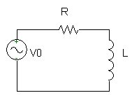

ECE 1101 Lab, Section 6

Date: Thursday, October 24th, 2019

Kyler Martinez, Daniel Tan

Equipment Used In The Experiment:

* Keysight Function/Arbitrary Waveform Generator 10Hz
  + Make/Model: 33210A
  + Serial Number: MY48017338
* Keysight InfiniiVision Digital Storage Oscilloscope 200 MHz
  + Make/Model: DSOX2022A
  + Serial Number: MY56041108
* GWINSTEK LCR-6002 Precision LCR Meter:
  + Make/Model: GWINSTEK LCR-6002
  + Serial Number: GES832591

Materials Used In The Experiment:

* Breadboard
* 10 mH Inductor
* 1k Ω resistor

Objective:

Students will use an oscilloscope to measure the time constant of the transient response of an RL circuit. Then, the theoretical RL transient equations are plotted and compared with patterns from the oscilloscope. Finally, students will create a PSPICE simulation to compare with and double-check the outcome.

Background Theory:

When a series RL circuit starting from a zero initial condition is introduced with a step voltage (E), the applied voltage will disperse across the inductor and resistor in accordance with the following equations: VL=E exp(-t/τ) for inductor voltage, IL=E/R [1-Exp(-t/τ)] for inductor or resistor current, and VR=E [1-Exp(-t/τ)] for resistor voltage. The time constant of the circuit is shown as ‘τ=L/R’; within an interval of one time constant from the beginning of the step. After capturing these particular levels on the oscilloscope screen, the time constant (τ) can then be determined. Combining this with the knowledge of R, the inductance can be computed as L=τmeasured/R.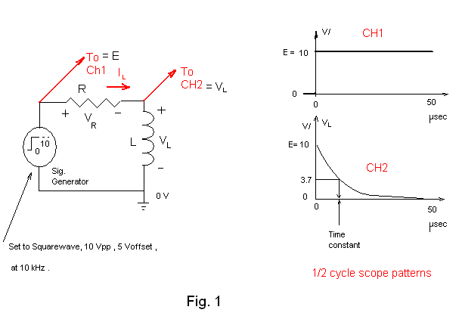

Procedure:

We first used the LCR meter to measure the inductance of our inductor and the internal wiring resistance of it. We then configured our breadboard to represent the circuit pictured in figure 1. We then set up the signal generator to produce a pulse wave and prepare the oscilloscope to take a voltage reading of the resistor and the inductor. We then allowed the oscilloscope to run and create a graph of the two voltages over time. We then use the cursors to determine the voltage supplied to the circuit and then find 37% of it to determine the voltage reading of our time constant. We then move the y-cursor to the voltage level and move the x cursor to match with the y-cursor and graph to find the time constant. We then used this to calculate the inductance of the inductor. We repeated this experiment but switching the positions of the inductor and resistor.

Data:

Component Measured Values

|  |  |  |
| --- | --- | --- |
| Plate Value | 10 mH | 1 kΩ |
| Measured Value | 10.175 mH, Internal Resistance 22.1563 Ω | N/A |

|  |  |  |
| --- | --- | --- |
|  | 𝛕 | L |
| Experimental/Oscilloscope | 9.9 µs | 9.9 mH |
| Calculated/Measured | 10.21 µs | 10.175 mH |
| Discrepancy | 3.03% | 2.703 % |

Conclusion:

By using the oscilloscope we were able to determine the inductance of the inductor to be about 9.9 mH which resulted in a 2.703% discrepancy. Our readings could have been closer if we had zoomed in more on the oscilloscope display, however, we wouldn’t have been able to see the output fully. Our value is still close to the measured value. We noticed that the E value was different sometimes which resulted in us having to alter what voltage we were looking for to determine the time constant. This could have been a slight error with the signal generator, but we don’t have any real reason to believe that. There could have been an issue with some of the internal wirings of our components but it wasn't too much of an effect on our results overall.

Post Lab Lab 9

PSPICE Simulation

Ideal Simulation

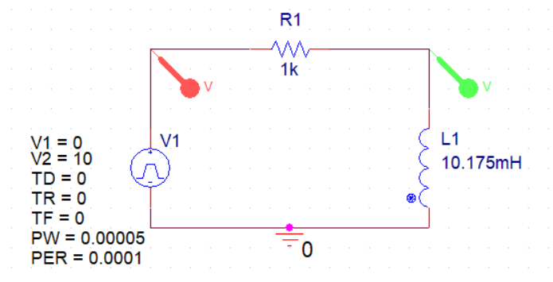

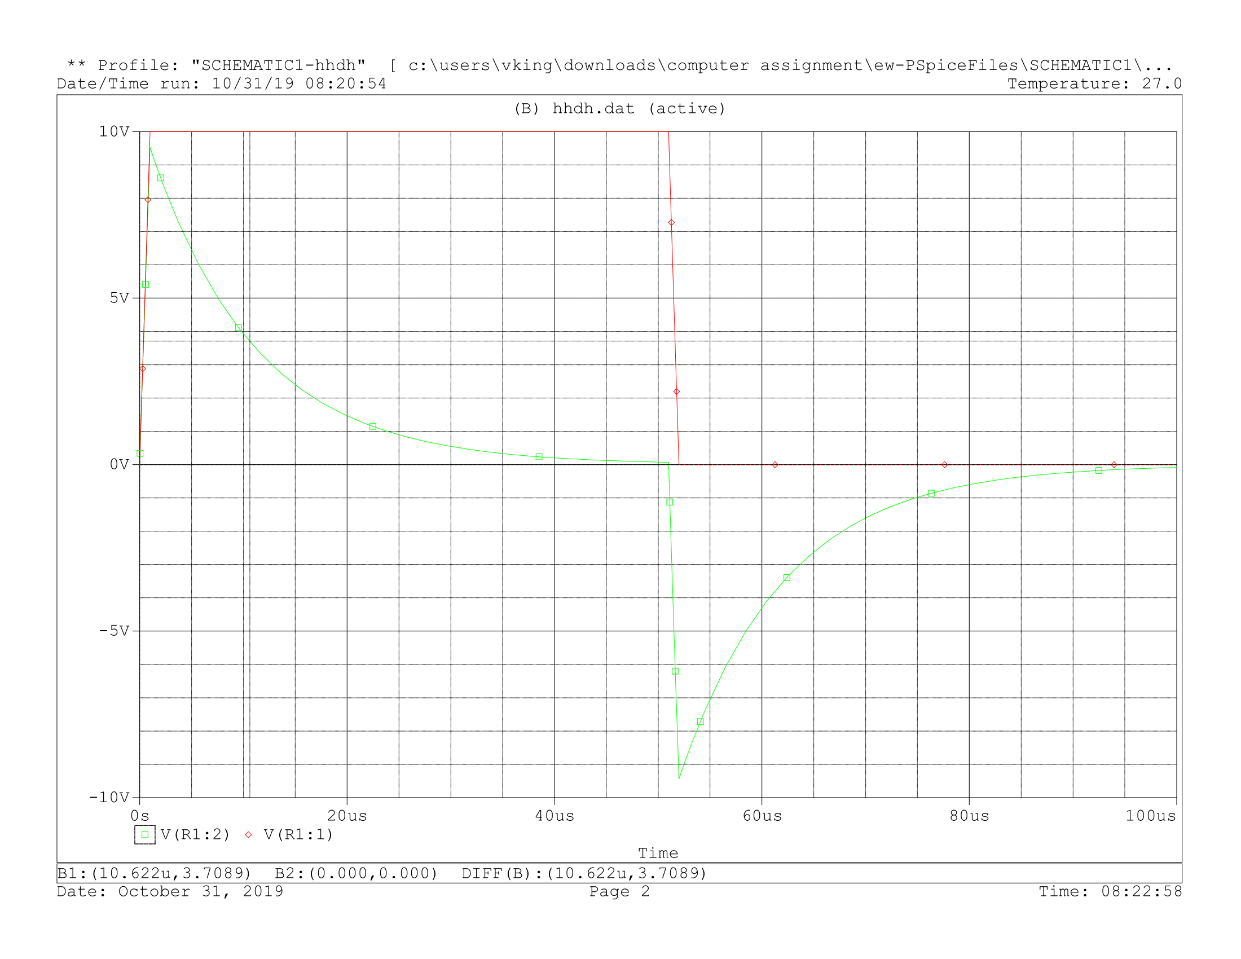

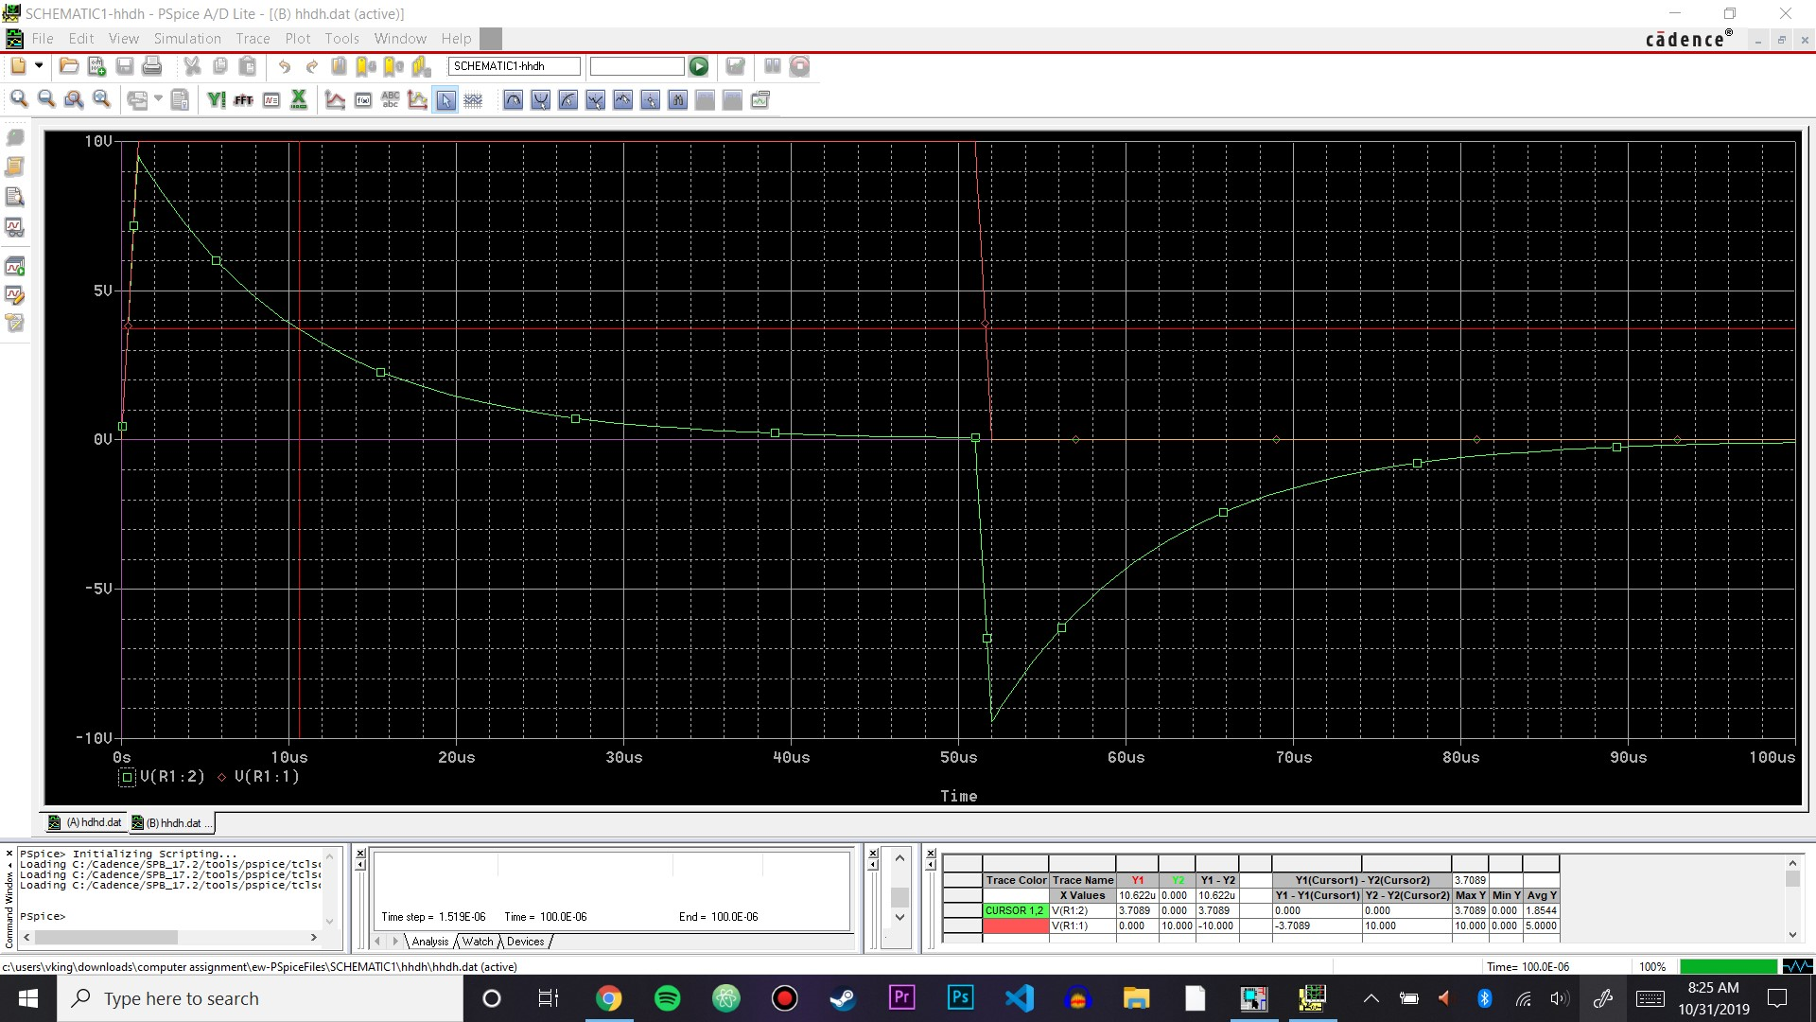

  
From the cursor, we get a time constant of about 10.622 µs, and the inductance of the inductor comes out to about 10.622 mH.

Realistic Simulation

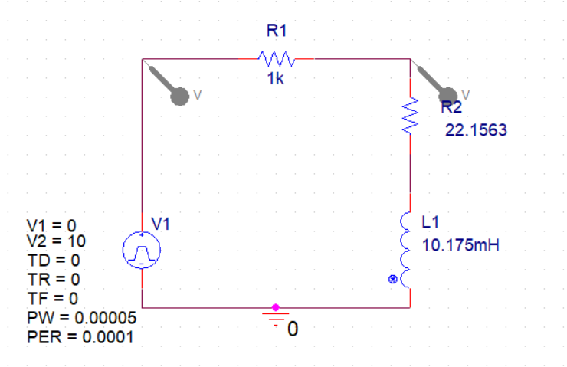

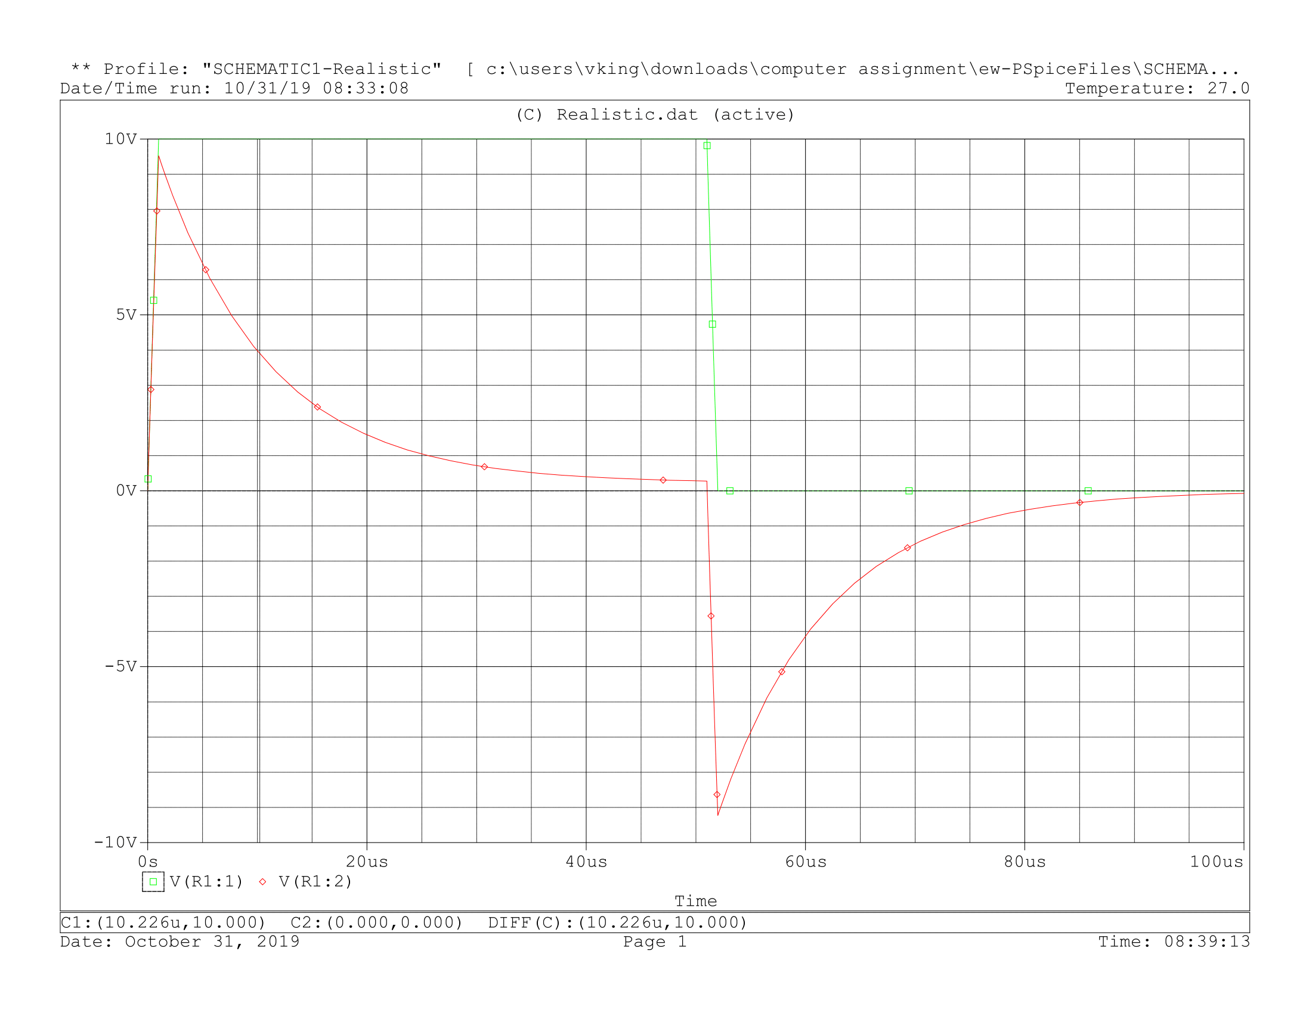

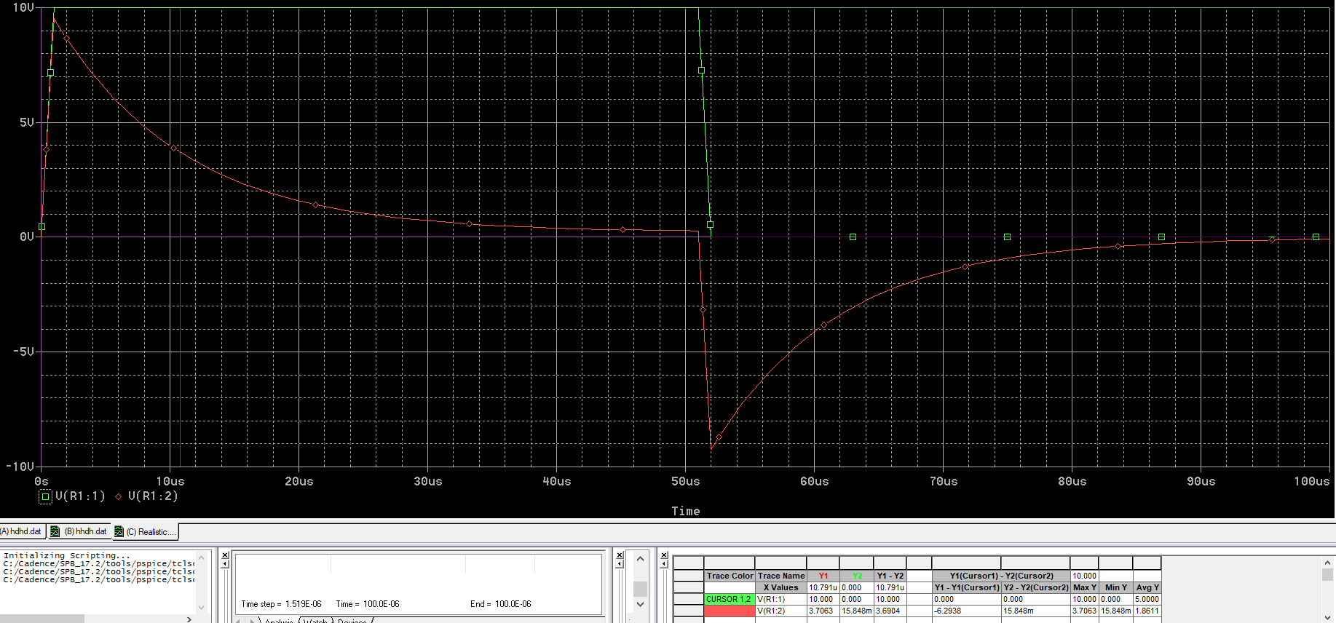



The time constant is about 10.791 µs and the inductance of the inductor is 10.791 mH.

Graphs from the Oscilloscope

Oscilloscope Reading When L and R are in the positions from Figure 1.

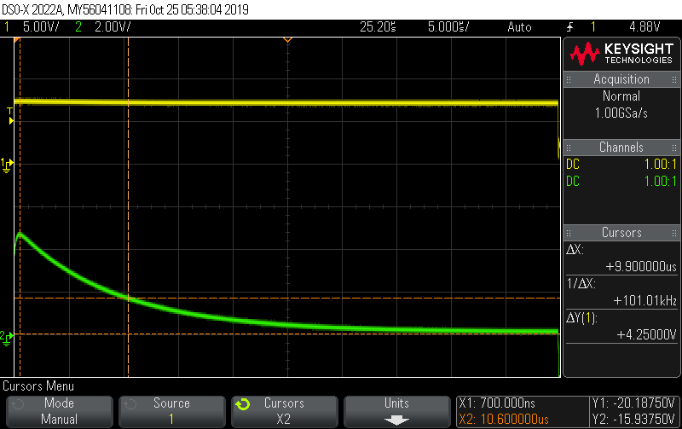

Oscilloscope Reading When L and R are switched.

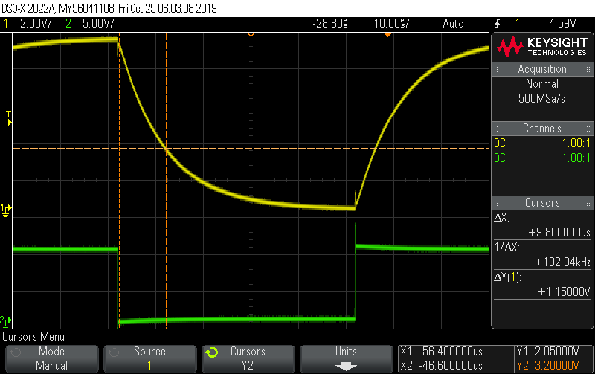

Graph Made Using Exponential Equations

VR = E( 1 – e-t/𝛕 ) , VL = E e-t/𝛕

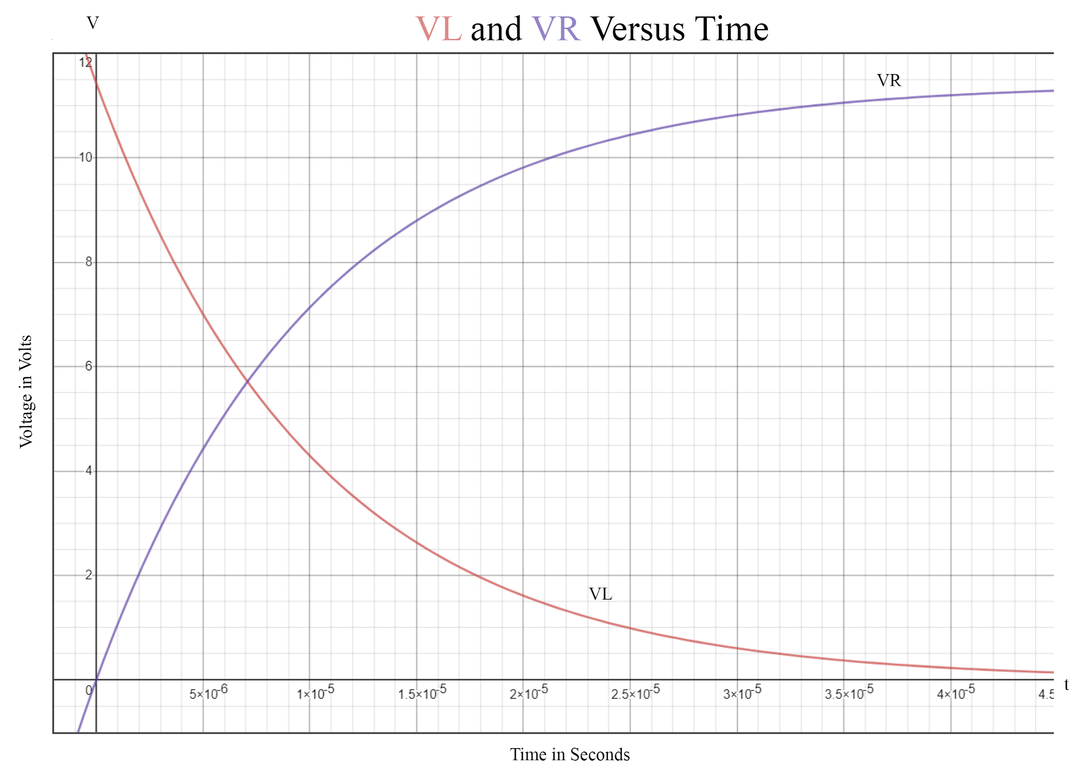

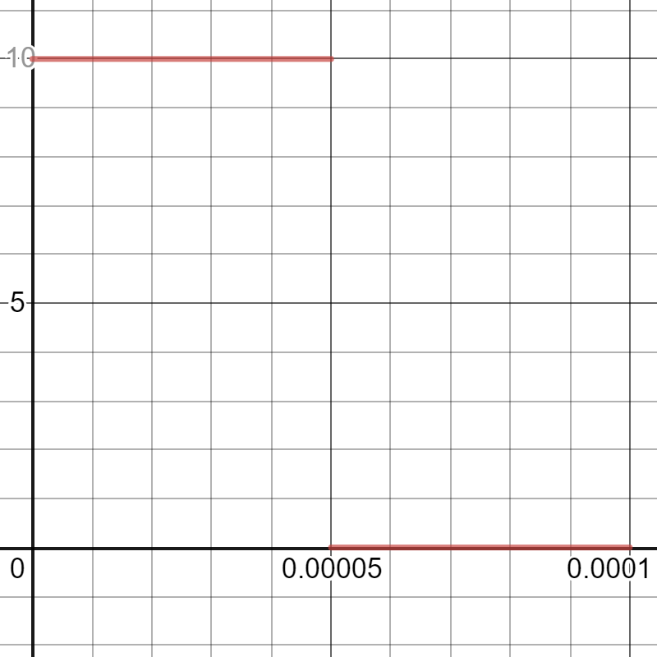

Voltage Input in Volts v Time in Seconds

Voltage (V)

Time (s)

Conclusion:

The graphs we did all match with the readings we got with the oscilloscope and with the graphs produced from the exponential equations and the square graph. There is a slight difference between all the different values with the biggest difference being in the values gained with the oscilloscopes, even the simulations. All the inductance measurements are around the value of 10.175 mH, which was found using the LCR meter. To produce different results we did use different simulations with the internal resistance of the inductor included in one. We also noticed when performing the reading that the E voltage on the oscilloscope was higher for the first test but lower on the second and we didn’t change any settings. We don’t know if there was an issue with the machine but we accommodated it to get the inductance that was relatively close to the measured value. Finally, there was the issue of using the cursors to get more precise measurement since they only went to a certain significant figure and it’s hard for a human to precisely move the cursor with a mouse to perfect values on the computer simulation without zooming the graph in really close, which loses sight of the graph.